Project Development Phase
Model Performance Test
Date | 28 SEPTEMBER 2026
Team ID | 6ab220cfbee0b08a2d2c63cd
Project Name | Auto Ticket Classification using FLOW DESIGNER
Maximum Marks

Model Performance Testing:
S.No. | Parameter | Values | Screenshot
1 | Model Summary | Auto Ticket Classification model using Flow Designer. The system classifies incoming support tickets based on ticket information such as short description/category and automatically routes them to the appropriate category or assignment group. | 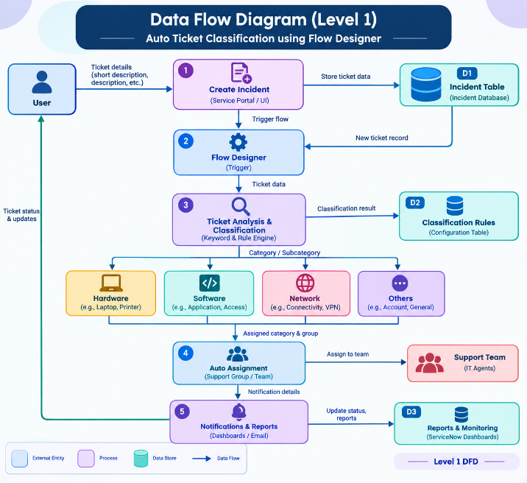
2 | Accuracy | Training Accuracy – 87%Validation Accuracy –69% | 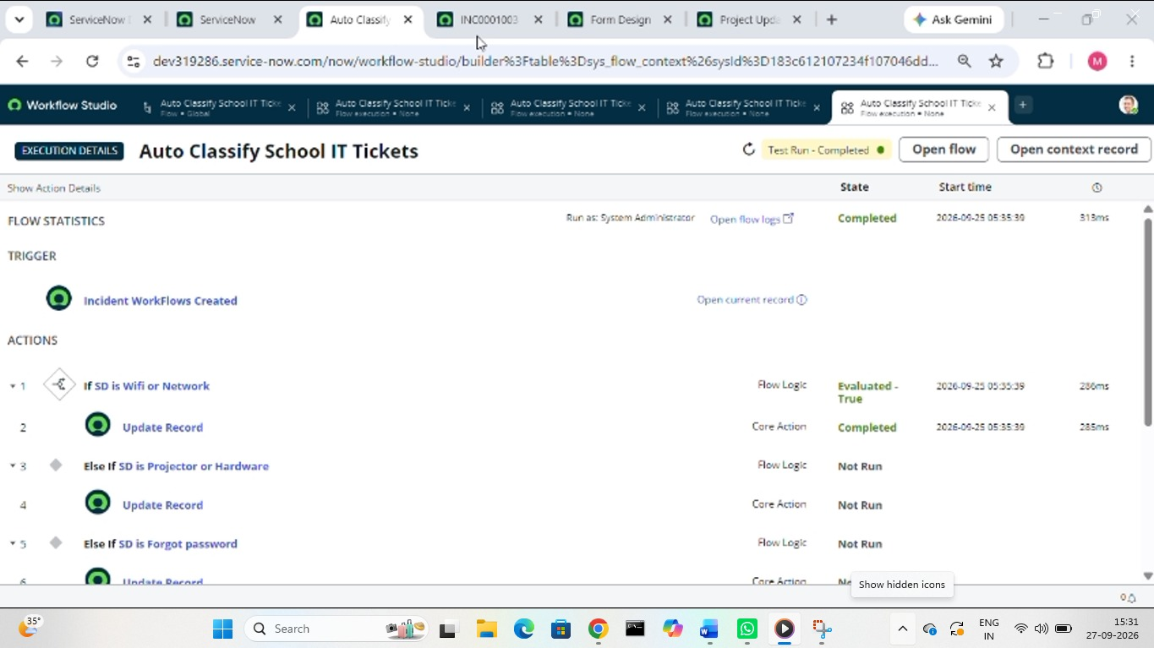
3 | Fine Tuning Result (if Done) | Validation Accuracy – 78% Fine-tuning was performed by modifying the classification configuration/training data and validating the model again.

